Using ANN to show whether a movie review has a positive or a negative sentiment.

**NOTE:** All output is shown in blue letters or input images

Python code:

import numpy as np

import pandas as pd

*# Input data files are available in the "../input/" directory.*

*# For example, running this (by clicking run or pressing Shift+Enter) will list the files in the input directory*

import os

print(os.listdir('C:/Users/x/Desktop/ML3rdProject/submission_ann.csv’))

*# Any results you write to the current directory are saved as output.*

['train.tsv', 'test.tsv', 'sampleSubmission.csv']

#Importing data Data

In [2]:

import warnings

warnings.filterwarnings('ignore')

import numpy as np

import pandas as pd

train = pd.read_csv('C:/Users/x/Desktop/ML3rdProject/submission_ann.csv /train.tsv',sep = '**\t**')

test = pd.read_csv(‘C:/Users/x/Desktop/ML3rdProject/submission_ann.csv /test.tsv', sep = '**\t**')

print("Train set: **{0}**".format(train.shape))

print("Test set: **{0}**".format(test.shape))

df = pd.concat([train, test])

print("All df set: **{0}**".format(df.shape))

df.head()

Train set: (156060, 4)

Test set: (66292, 3)

All df set: (222352, 4)

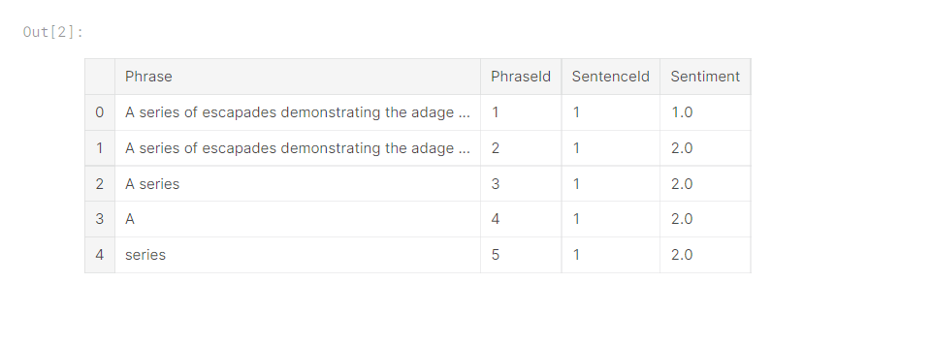In [3]:

sub = pd.read_csv('C:/Users/x/Desktop/ML3rdProject/submission_ann.csv/sampleSubmission.csv', sep = ',')

print("Submission: **{0}**".format(sub.shape))

sub.head()

Submission: (66292, 2)

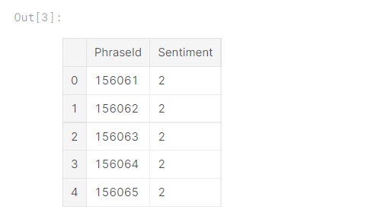

In [4]:

x = train.groupby(['Sentiment'])['PhraseId'].count()

x.plot.bar()

Out[4]:

<matplotlib.axes._subplots.AxesSubplot at 0x7f9b5087dda0>

#Now we analyze the distribution of different groups

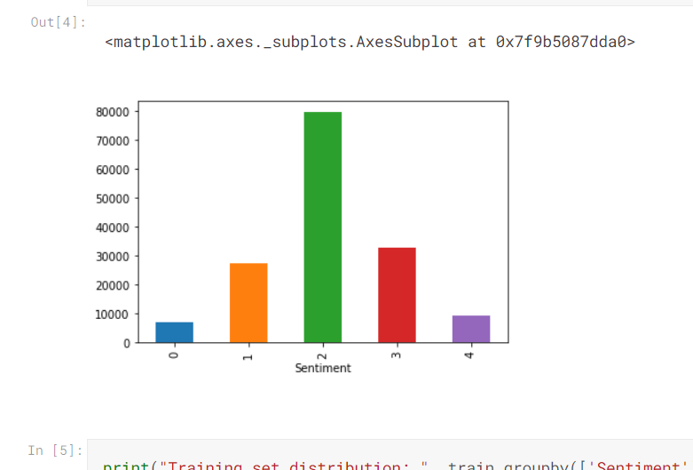

In [5]:

print("Training set distribution: ", train.groupby(['Sentiment']).size()/train.shape[0])

Training set distribution: Sentiment

0 0.045316

1 0.174760

2 0.509945

3 0.210989

4 0.058990

dtype: float64

#Cleaning data

In [6]:

import re

from nltk.stem import PorterStemmer

stemmer = PorterStemmer()

from nltk.stem import WordNetLemmatizer

wordnet_lemmatizer = WordNetLemmatizer()

In [7]:

def clean_text(text):

text = text.lower()

text = re.sub(r"[-()**\"**#/@;:<>**{}**+=~|.?,]", "", text)

review_lemma=[]

for word **in** text.split():

word_lemma = wordnet_lemmatizer.lemmatize(word)

review_lemma.append(word_lemma)

review_lemma=' '.join(review_lemma)

return review_lemma

In [8]:

train['clean_phrase'] = train['Phrase'].apply(clean_text)

test['clean_phrase'] = test['Phrase'].apply(clean_text)

df['clean_phrase'] = df['Phrase'].apply(clean_text)

In [9]:

train.head()

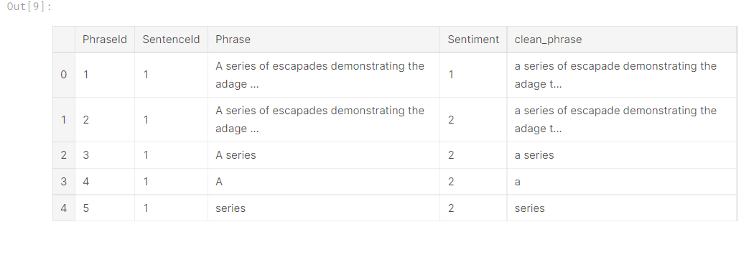

#Counting different features from reviews

In [10]:

from keras.utils import to_categorical

from sklearn.model_selection import train_test_split

from nltk.tokenize import word_tokenize

from nltk import FreqDist

Using TensorFlow backend.

In [11]:

train_text=train.clean_phrase.values

test_text=test.clean_phrase.values

target=train.Sentiment.values

y=to_categorical(target)

print(train_text.shape,target.shape,y.shape)

(156060,) (156060,) (156060, 5)

In [12]:

X_train_text,X_val_text,y_train,y_val=train_test_split(train_text,y,test_size=0.2,stratify=y,random_state=123)

print(X_train_text.shape,y_train.shape)

print(X_val_text.shape,y_val.shape)

(124848,) (124848, 5)

(31212,) (31212, 5)

In [13]:

all_words = ' '.join(X_train_text)

word2count = {}

for word **in** all_words.split():

if word **not** **in** word2count:

word2count[word] = 1

else:

word2count[word] += 1

print("Number of unique words: ", len(word2count.keys()))

Number of unique words: 15070

In [14]:

df['length_review'] = df['clean_phrase'].apply(lambda x: len(x.split()))

print("Max phrase length: ", max(df['length_review']))

Max phrase length: 52

#Processing the common features of the reviews

In [15]:

d = pd.DataFrame(list(word2count.items()), columns=['word', 'count'])

d.head()

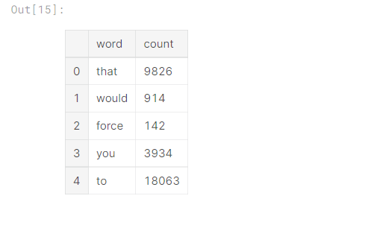

In [16]:

all_phrases = [X_train_text]

all_phrases

Out[16]:

[array(['that would force you to give it a millisecond of thought',

'joyful', 'might enjoy this', ..., 'c walsh', 'a while a meander',

"think you 've figured out late marriage"], dtype=object)]

In [17]:

*from sklearn.feature_extraction.text import TfidfTransformer*

*sklearn_tfidf = TfidfTransformer()*

*sklearn_representation = sklearn_tfidf.fit_transform(all_phrases)*

#Tokenizer and Sequence padding - Extracting and applying padding to sequences of tokens to use to train deep learning models with Tensorflow.

In [18]:

from keras.preprocessing.text import Tokenizer

from keras.preprocessing.sequence import pad_sequences

In [19]:

MAX_REVIEW_LENGTH = 49

FEATURE_LENGTH = 12011

BATCH_SIZE = 1000

EPOCHS = 100

NUM_CLASSES = 5

In [20]:

tokenizer = Tokenizer(num_words = FEATURE_LENGTH)

tokenizer.fit_on_texts(list(np.concatenate((train_text, test_text), axis=0)))

X_train = tokenizer.texts_to_sequences(X_train_text)

X_val = tokenizer.texts_to_sequences(X_val_text)

X_test = tokenizer.texts_to_sequences(test_text)

In [21]:

X_train = pad_sequences(X_train, maxlen=MAX_REVIEW_LENGTH)

X_val = pad_sequences(X_val, maxlen=MAX_REVIEW_LENGTH)

X_test= pad_sequences(X_test, maxlen=MAX_REVIEW_LENGTH)

#Using random Forest

In [22]:

from keras.models import Sequential

from keras.layers import Dense,Dropout,Embedding,LSTM,Conv1D,GlobalMaxPooling1D

from keras.losses import categorical_crossentropy

from keras.optimizers import Adam

In [23]:

model=Sequential()

model.add(Embedding(FEATURE_LENGTH,250,mask_zero=True))

model.add(LSTM(128,dropout=0.4, recurrent_dropout=0.4,return_sequences=True))

model.add(LSTM(64,dropout=0.5, recurrent_dropout=0.5,return_sequences=False))

model.add(Dense(NUM_CLASSES,activation='softmax'))

model.compile(loss='categorical_crossentropy',optimizer=Adam(lr=0.001),metrics=['accuracy'])

model.summary()

_________________________________________________________________

Layer (type) Output Shape Param #

=================================================================

embedding_1 (Embedding) (None, None, 250) 3002750

_________________________________________________________________

lstm_1 (LSTM) (None, None, 128) 194048

_________________________________________________________________

lstm_2 (LSTM) (None, 64) 49408

_________________________________________________________________

dense_1 (Dense) (None, 5) 325

=================================================================

Total params: 3,246,531

Trainable params: 3,246,531

Non-trainable params: 0

_________________________________________________________________

In [24]:

history = model.fit(X_train, y_train, validation_data=(X_val, y_val),epochs=EPOCHS, batch_size=BATCH_SIZE, verbose=1)

Train on 124848 samples, validate on 31212 samples

Epoch 1/100

124848/124848 [==============================] - 51s 407us/step - loss: 1.2661 - acc: 0.5339 - val_loss: 0.9983 - val_acc: 0.6140

Epoch 2/100

124848/124848 [==============================] - 45s 357us/step - loss: 0.9214 - acc: 0.6389 - val_loss: 0.8908 - val_acc: 0.6471

Epoch 3/100

124848/124848 [==============================] - 45s 358us/step - loss: 0.8394 - acc: 0.6662 - val_loss: 0.8719 - val_acc: 0.6560

Epoch 4/100

124848/124848 [==============================] - 45s 357us/step - loss: 0.8040 - acc: 0.6798 - val_loss: 0.8653 - val_acc: 0.6562

Epoch 5/100

124848/124848 [==============================] - 44s 356us/step - loss: 0.7805 - acc: 0.6878 - val_loss: 0.8628 - val_acc: 0.6604

Epoch 6/100

124848/124848 [==============================] - 45s 357us/step - loss: 0.7595 - acc: 0.6968 - val_loss: 0.8617 - val_acc: 0.6606

Epoch 7/100

124848/124848 [==============================] - 45s 358us/step - loss: 0.7436 - acc: 0.7011 - val_loss: 0.8586 - val_acc: 0.6625

Epoch 8/100

124848/124848 [==============================] - 45s 357us/step - loss: 0.7272 - acc: 0.7074 - val_loss: 0.8615 - val_acc: 0.6630

Epoch 9/100

124848/124848 [==============================] - 45s 358us/step - loss: 0.7122 - acc: 0.7125 - val_loss: 0.8667 - val_acc: 0.6630

Epoch 10/100

124848/124848 [==============================] - 44s 356us/step - loss: 0.7001 - acc: 0.7156 - val_loss: 0.8672 - val_acc: 0.6616

Epoch 11/100

124848/124848 [==============================] - 45s 358us/step - loss: 0.6862 - acc: 0.7211 - val_loss: 0.8703 - val_acc: 0.6639

Epoch 12/100

124848/124848 [==============================] - 44s 355us/step - loss: 0.6732 - acc: 0.7256 - val_loss: 0.8705 - val_acc: 0.6626

Epoch 13/100

124848/124848 [==============================] - 45s 358us/step - loss: 0.6628 - acc: 0.7287 - val_loss: 0.8764 - val_acc: 0.6661

Epoch 14/100

124848/124848 [==============================] - 45s 357us/step - loss: 0.6499 - acc: 0.7326 - val_loss: 0.8828 - val_acc: 0.6635

Epoch 15/100

124848/124848 [==============================] - 45s 358us/step - loss: 0.6377 - acc: 0.7369 - val_loss: 0.8921 - val_acc: 0.6648

Epoch 16/100

124848/124848 [==============================] - 45s 358us/step - loss: 0.6276 - acc: 0.7398 - val_loss: 0.8948 - val_acc: 0.6638

Epoch 17/100

124848/124848 [==============================] - 45s 357us/step - loss: 0.6154 - acc: 0.7448 - val_loss: 0.9075 - val_acc: 0.6616

Epoch 18/100

124848/124848 [==============================] - 44s 355us/step - loss: 0.6058 - acc: 0.7474 - val_loss: 0.9106 - val_acc: 0.6610

Epoch 19/100

124848/124848 [==============================] - 44s 354us/step - loss: 0.5955 - acc: 0.7499 - val_loss: 0.9312 - val_acc: 0.6612

Epoch 20/100

124848/124848 [==============================] - 44s 355us/step - loss: 0.5868 - acc: 0.7543 - val_loss: 0.9354 - val_acc: 0.6615

Epoch 21/100

124848/124848 [==============================] - 44s 354us/step - loss: 0.5770 - acc: 0.7561 - val_loss: 0.9487 - val_acc: 0.6590

Epoch 22/100

124848/124848 [==============================] - 44s 354us/step - loss: 0.5694 - acc: 0.7604 - val_loss: 0.9635 - val_acc: 0.6577

Epoch 23/100

124848/124848 [==============================] - 44s 354us/step - loss: 0.5608 - acc: 0.7626 - val_loss: 0.9668 - val_acc: 0.6608

Epoch 24/100

124848/124848 [==============================] - 44s 353us/step - loss: 0.5532 - acc: 0.7653 - val_loss: 0.9893 - val_acc: 0.6574

Epoch 25/100

124848/124848 [==============================] - 44s 353us/step - loss: 0.5464 - acc: 0.7677 - val_loss: 0.9978 - val_acc: 0.6538

Epoch 26/100

124848/124848 [==============================] - 44s 354us/step - loss: 0.5387 - acc: 0.7717 - val_loss: 1.0145 - val_acc: 0.6542

Epoch 27/100

124848/124848 [==============================] - 44s 354us/step - loss: 0.5342 - acc: 0.7701 - val_loss: 1.0291 - val_acc: 0.6520

Epoch 28/100

124848/124848 [==============================] - 44s 353us/step - loss: 0.5256 - acc: 0.7743 - val_loss: 1.0432 - val_acc: 0.6554

Epoch 29/100

124848/124848 [==============================] - 44s 352us/step - loss: 0.5187 - acc: 0.7788 - val_loss: 1.0571 - val_acc: 0.6538

Epoch 30/100

124848/124848 [==============================] - 44s 355us/step - loss: 0.5138 - acc: 0.7789 - val_loss: 1.0665 - val_acc: 0.6502

Epoch 31/100

124848/124848 [==============================] - 44s 353us/step - loss: 0.5079 - acc: 0.7826 - val_loss: 1.0888 - val_acc: 0.6512

Epoch 32/100

124848/124848 [==============================] - 44s 354us/step - loss: 0.5011 - acc: 0.7849 - val_loss: 1.1098 - val_acc: 0.6522

Epoch 33/100

124848/124848 [==============================] - 44s 353us/step - loss: 0.4983 - acc: 0.7854 - val_loss: 1.1069 - val_acc: 0.6498

Epoch 34/100

124848/124848 [==============================] - 44s 353us/step - loss: 0.4934 - acc: 0.7878 - val_loss: 1.1229 - val_acc: 0.6505

Epoch 35/100

124848/124848 [==============================] - 44s 353us/step - loss: 0.4866 - acc: 0.7902 - val_loss: 1.1407 - val_acc: 0.6492

Epoch 36/100

124848/124848 [==============================] - 44s 353us/step - loss: 0.4833 - acc: 0.7926 - val_loss: 1.1525 - val_acc: 0.6463

Epoch 37/100

124848/124848 [==============================] - 44s 352us/step - loss: 0.4791 - acc: 0.7937 - val_loss: 1.1517 - val_acc: 0.6467

Epoch 38/100

124848/124848 [==============================] - 44s 352us/step - loss: 0.4734 - acc: 0.7956 - val_loss: 1.1669 - val_acc: 0.6484

Epoch 39/100

124848/124848 [==============================] - 44s 352us/step - loss: 0.4692 - acc: 0.7977 - val_loss: 1.1843 - val_acc: 0.6463

Epoch 40/100

124848/124848 [==============================] - 44s 353us/step - loss: 0.4650 - acc: 0.7996 - val_loss: 1.1945 - val_acc: 0.6464

Epoch 41/100

124848/124848 [==============================] - 44s 353us/step - loss: 0.4611 - acc: 0.8007 - val_loss: 1.2126 - val_acc: 0.6475

Epoch 42/100

124848/124848 [==============================] - 44s 352us/step - loss: 0.4572 - acc: 0.8018 - val_loss: 1.2169 - val_acc: 0.6439

Epoch 43/100

124848/124848 [==============================] - 44s 355us/step - loss: 0.4527 - acc: 0.8043 - val_loss: 1.2461 - val_acc: 0.6435

Epoch 44/100

124848/124848 [==============================] - 44s 356us/step - loss: 0.4483 - acc: 0.8069 - val_loss: 1.2594 - val_acc: 0.6440

Epoch 45/100

124848/124848 [==============================] - 44s 356us/step - loss: 0.4463 - acc: 0.8065 - val_loss: 1.2630 - val_acc: 0.6438

Epoch 46/100

124848/124848 [==============================] - 44s 356us/step - loss: 0.4425 - acc: 0.8087 - val_loss: 1.2657 - val_acc: 0.6427

Epoch 47/100

124848/124848 [==============================] - 44s 355us/step - loss: 0.4382 - acc: 0.8098 - val_loss: 1.2981 - val_acc: 0.6392

Epoch 48/100

124848/124848 [==============================] - 44s 352us/step - loss: 0.4368 - acc: 0.8111 - val_loss: 1.2981 - val_acc: 0.6400

Epoch 49/100

124848/124848 [==============================] - 44s 353us/step - loss: 0.4305 - acc: 0.8127 - val_loss: 1.3089 - val_acc: 0.6408

Epoch 50/100

124848/124848 [==============================] - 44s 355us/step - loss: 0.4279 - acc: 0.8134 - val_loss: 1.3255 - val_acc: 0.6371

Epoch 51/100

108000/124848 [========================>.....] - ETA: 5s - loss: 0.4225 - acc: 0.8178

In [25]:

y_pred = model.predict_classes(X_test)

In [26]:

test["Sentiment"] = y_pred

In [27]:

test[['PhraseId', 'Sentiment']].to_csv('submission_lstm.csv', index = False)

#ANN

In [28]:

from keras.layers import Flatten

In [29]:

ann_model = Sequential()

ann_model.add(Embedding(FEATURE_LENGTH,250, input_length=MAX_REVIEW_LENGTH))

ann_model.add(Dense(output_dim = 100, init = 'uniform', activation = 'relu'))

ann_model.add(Flatten())

ann_model.add(Dense(output_dim = 50, activation='tanh'))

ann_model.add(Dense(output_dim = 10, activation = 'relu'))

ann_model.add(Dense(NUM_CLASSES,activation='softmax'))

ann_model.compile(optimizer=Adam(lr=0.001), loss = 'categorical_crossentropy', metrics = ['accuracy'])

ann_model.summary()

_________________________________________________________________

Layer (type) Output Shape Param #

=================================================================

embedding_2 (Embedding) (None, 49, 250) 3002750

_________________________________________________________________

dense_2 (Dense) (None, 49, 100) 25100

_________________________________________________________________

flatten_1 (Flatten) (None, 4900) 0

_________________________________________________________________

dense_3 (Dense) (None, 50) 245050

_________________________________________________________________

dense_4 (Dense) (None, 10) 510

_________________________________________________________________

dense_5 (Dense) (None, 5) 55

=================================================================

Total params: 3,273,465

Trainable params: 3,273,465

Non-trainable params: 0

_________________________________________________________________

In [30]:

ann_history = ann_model.fit(X_train, y_train, validation_data=(X_val, y_val), batch_size = BATCH_SIZE, epochs = EPOCHS)

Train on 124848 samples, validate on 31212 samples

Epoch 1/100

124848/124848 [==============================] - 4s 28us/step - loss: 1.1862 - acc: 0.5273 - val_loss: 0.9932 - val_acc: 0.6050

Epoch 2/100

124848/124848 [==============================] - 3s 23us/step - loss: 0.8747 - acc: 0.6527 - val_loss: 0.8614 - val_acc: 0.6557

Epoch 3/100

124848/124848 [==============================] - 3s 23us/step - loss: 0.7659 - acc: 0.6915 - val_loss: 0.8454 - val_acc: 0.6611

Epoch 4/100

124848/124848 [==============================] - 3s 23us/step - loss: 0.7104 - acc: 0.7115 - val_loss: 0.8494 - val_acc: 0.6607

Epoch 5/100

124848/124848 [==============================] - 3s 23us/step - loss: 0.6694 - acc: 0.7267 - val_loss: 0.8588 - val_acc: 0.6535

Epoch 6/100

124848/124848 [==============================] - 3s 23us/step - loss: 0.6367 - acc: 0.7399 - val_loss: 0.8723 - val_acc: 0.6589

Epoch 7/100

124848/124848 [==============================] - 3s 23us/step - loss: 0.6099 - acc: 0.7491 - val_loss: 0.8906 - val_acc: 0.6588

Epoch 8/100

124848/124848 [==============================] - 3s 23us/step - loss: 0.5870 - acc: 0.7568 - val_loss: 0.9114 - val_acc: 0.6515

Epoch 9/100

124848/124848 [==============================] - 3s 23us/step - loss: 0.5664 - acc: 0.7632 - val_loss: 0.9333 - val_acc: 0.6527

Epoch 10/100

124848/124848 [==============================] - 3s 23us/step - loss: 0.5496 - acc: 0.7686 - val_loss: 0.9550 - val_acc: 0.6484

Epoch 11/100

124848/124848 [==============================] - 3s 23us/step - loss: 0.5344 - acc: 0.7744 - val_loss: 0.9720 - val_acc: 0.6481

Epoch 12/100

124848/124848 [==============================] - 3s 23us/step - loss: 0.5216 - acc: 0.7781 - val_loss: 0.9933 - val_acc: 0.6492

Epoch 13/100

124848/124848 [==============================] - 3s 23us/step - loss: 0.5090 - acc: 0.7815 - val_loss: 1.0172 - val_acc: 0.6446

Epoch 14/100

124848/124848 [==============================] - 3s 23us/step - loss: 0.4975 - acc: 0.7851 - val_loss: 1.0363 - val_acc: 0.6448

Epoch 15/100

124848/124848 [==============================] - 3s 23us/step - loss: 0.4856 - acc: 0.7896 - val_loss: 1.0562 - val_acc: 0.6382

Epoch 16/100

124848/124848 [==============================] - 3s 23us/step - loss: 0.4747 - acc: 0.7925 - val_loss: 1.0768 - val_acc: 0.6421

Epoch 17/100

124848/124848 [==============================] - 3s 23us/step - loss: 0.4666 - acc: 0.7945 - val_loss: 1.0993 - val_acc: 0.6368

Epoch 18/100

124848/124848 [==============================] - 3s 23us/step - loss: 0.4574 - acc: 0.7978 - val_loss: 1.1123 - val_acc: 0.6372

Epoch 19/100

124848/124848 [==============================] - 3s 23us/step - loss: 0.4494 - acc: 0.8002 - val_loss: 1.1399 - val_acc: 0.6381

Epoch 20/100

124848/124848 [==============================] - 3s 23us/step - loss: 0.4411 - acc: 0.8037 - val_loss: 1.1720 - val_acc: 0.6377

Epoch 21/100

124848/124848 [==============================] - 3s 23us/step - loss: 0.4340 - acc: 0.8051 - val_loss: 1.1884 - val_acc: 0.6346

Epoch 22/100

124848/124848 [==============================] - 3s 23us/step - loss: 0.4265 - acc: 0.8081 - val_loss: 1.2148 - val_acc: 0.6345

Epoch 23/100

124848/124848 [==============================] - 3s 23us/step - loss: 0.4189 - acc: 0.8099 - val_loss: 1.2338 - val_acc: 0.6349

Epoch 24/100

124848/124848 [==============================] - 3s 23us/step - loss: 0.4131 - acc: 0.8123 - val_loss: 1.2482 - val_acc: 0.6367

Epoch 25/100

124848/124848 [==============================] - 3s 23us/step - loss: 0.4064 - acc: 0.8149 - val_loss: 1.2779 - val_acc: 0.6301

Epoch 26/100

124848/124848 [==============================] - 3s 23us/step - loss: 0.3994 - acc: 0.8174 - val_loss: 1.2907 - val_acc: 0.6316

Epoch 27/100

124848/124848 [==============================] - 3s 23us/step - loss: 0.3937 - acc: 0.8199 - val_loss: 1.3238 - val_acc: 0.6354

Epoch 28/100

124848/124848 [==============================] - 3s 23us/step - loss: 0.3869 - acc: 0.8218 - val_loss: 1.3420 - val_acc: 0.6309

Epoch 29/100

124848/124848 [==============================] - 3s 23us/step - loss: 0.3806 - acc: 0.8239 - val_loss: 1.3702 - val_acc: 0.6275

Epoch 30/100

124848/124848 [==============================] - 3s 23us/step - loss: 0.3748 - acc: 0.8263 - val_loss: 1.3916 - val_acc: 0.6309

Epoch 31/100

124848/124848 [==============================] - 3s 23us/step - loss: 0.3692 - acc: 0.8288 - val_loss: 1.4139 - val_acc: 0.6308

Epoch 32/100

124848/124848 [==============================] - 3s 23us/step - loss: 0.3639 - acc: 0.8319 - val_loss: 1.4357 - val_acc: 0.6257

Epoch 33/100

124848/124848 [==============================] - 3s 23us/step - loss: 0.3580 - acc: 0.8335 - val_loss: 1.4525 - val_acc: 0.6269

Epoch 34/100

124848/124848 [==============================] - 3s 23us/step - loss: 0.3513 - acc: 0.8365 - val_loss: 1.4711 - val_acc: 0.6249

Epoch 35/100

124848/124848 [==============================] - 3s 23us/step - loss: 0.3460 - acc: 0.8386 - val_loss: 1.5060 - val_acc: 0.6242

Epoch 36/100

124848/124848 [==============================] - 3s 23us/step - loss: 0.3402 - acc: 0.8420 - val_loss: 1.5252 - val_acc: 0.6246

Epoch 37/100

124848/124848 [==============================] - 3s 23us/step - loss: 0.3344 - acc: 0.8446 - val_loss: 1.5562 - val_acc: 0.6243

Epoch 38/100

124848/124848 [==============================] - 3s 23us/step - loss: 0.3287 - acc: 0.8468 - val_loss: 1.6023 - val_acc: 0.6283

Epoch 39/100

124848/124848 [==============================] - 3s 23us/step - loss: 0.3228 - acc: 0.8497 - val_loss: 1.6070 - val_acc: 0.6252

Epoch 40/100

124848/124848 [==============================] - 3s 23us/step - loss: 0.3185 - acc: 0.8519 - val_loss: 1.6321 - val_acc: 0.6246

Epoch 41/100

124848/124848 [==============================] - 3s 23us/step - loss: 0.3123 - acc: 0.8549 - val_loss: 1.6629 - val_acc: 0.6214

Epoch 42/100

124848/124848 [==============================] - 3s 23us/step - loss: 0.3064 - acc: 0.8582 - val_loss: 1.7207 - val_acc: 0.6188

Epoch 43/100

124848/124848 [==============================] - 3s 23us/step - loss: 0.3000 - acc: 0.8612 - val_loss: 1.7255 - val_acc: 0.6243

Epoch 44/100

124848/124848 [==============================] - 3s 23us/step - loss: 0.2939 - acc: 0.8637 - val_loss: 1.7552 - val_acc: 0.6183

Epoch 45/100

124848/124848 [==============================] - 3s 23us/step - loss: 0.2894 - acc: 0.8672 - val_loss: 1.7896 - val_acc: 0.6211

Epoch 46/100

124848/124848 [==============================] - 3s 23us/step - loss: 0.2829 - acc: 0.8698 - val_loss: 1.8336 - val_acc: 0.6216

Epoch 47/100

124848/124848 [==============================] - 3s 23us/step - loss: 0.2772 - acc: 0.8728 - val_loss: 1.8612 - val_acc: 0.6184

Epoch 48/100

124848/124848 [==============================] - 3s 23us/step - loss: 0.2725 - acc: 0.8755 - val_loss: 1.8939 - val_acc: 0.6140

Epoch 49/100

124848/124848 [==============================] - 3s 23us/step - loss: 0.2665 - acc: 0.8778 - val_loss: 1.8899 - val_acc: 0.6186

Epoch 50/100

124848/124848 [==============================] - 3s 23us/step - loss: 0.2603 - acc: 0.8821 - val_loss: 1.9506 - val_acc: 0.6163

Epoch 51/100

124848/124848 [==============================] - 3s 23us/step - loss: 0.2544 - acc: 0.8844 - val_loss: 1.9620 - val_acc: 0.6186

Epoch 52/100

124848/124848 [==============================] - 3s 23us/step - loss: 0.2493 - acc: 0.8871 - val_loss: 2.0095 - val_acc: 0.6172

Epoch 53/100

124848/124848 [==============================] - 3s 23us/step - loss: 0.2457 - acc: 0.8884 - val_loss: 2.0228 - val_acc: 0.6159

Epoch 54/100

124848/124848 [==============================] - 3s 23us/step - loss: 0.2400 - acc: 0.8916 - val_loss: 2.0603 - val_acc: 0.6150

Epoch 55/100

124848/124848 [==============================] - 3s 23us/step - loss: 0.2337 - acc: 0.8936 - val_loss: 2.1149 - val_acc: 0.6133

Epoch 56/100

124848/124848 [==============================] - 3s 23us/step - loss: 0.2280 - acc: 0.8960 - val_loss: 2.1472 - val_acc: 0.6164

Epoch 57/100

124848/124848 [==============================] - 3s 23us/step - loss: 0.2244 - acc: 0.8984 - val_loss: 2.1537 - val_acc: 0.6154

Epoch 58/100

124848/124848 [==============================] - 3s 23us/step - loss: 0.2192 - acc: 0.9000 - val_loss: 2.2011 - val_acc: 0.6151

Epoch 59/100

124848/124848 [==============================] - 3s 23us/step - loss: 0.2147 - acc: 0.9025 - val_loss: 2.2371 - val_acc: 0.6129

Epoch 60/100

124848/124848 [==============================] - 3s 23us/step - loss: 0.2100 - acc: 0.9053 - val_loss: 2.2626 - val_acc: 0.6155

Epoch 61/100

124848/124848 [==============================] - 3s 23us/step - loss: 0.2061 - acc: 0.9064 - val_loss: 2.2751 - val_acc: 0.6137

Epoch 62/100

124848/124848 [==============================] - 3s 23us/step - loss: 0.2022 - acc: 0.9083 - val_loss: 2.3141 - val_acc: 0.6115

Epoch 63/100

124848/124848 [==============================] - 3s 23us/step - loss: 0.1985 - acc: 0.9094 - val_loss: 2.3502 - val_acc: 0.6122

Epoch 64/100

124848/124848 [==============================] - 3s 23us/step - loss: 0.1951 - acc: 0.9106 - val_loss: 2.3863 - val_acc: 0.6132

Epoch 65/100

124848/124848 [==============================] - 3s 23us/step - loss: 0.1910 - acc: 0.9125 - val_loss: 2.4010 - val_acc: 0.6118

Epoch 66/100

124848/124848 [==============================] - 3s 23us/step - loss: 0.1866 - acc: 0.9145 - val_loss: 2.4213 - val_acc: 0.6118

Epoch 67/100

124848/124848 [==============================] - 3s 23us/step - loss: 0.1842 - acc: 0.9159 - val_loss: 2.4621 - val_acc: 0.6117

Epoch 68/100

124848/124848 [==============================] - 3s 23us/step - loss: 0.1820 - acc: 0.9159 - val_loss: 2.4772 - val_acc: 0.6110

Epoch 69/100

124848/124848 [==============================] - 3s 23us/step - loss: 0.1807 - acc: 0.9171 - val_loss: 2.4701 - val_acc: 0.6110

Epoch 70/100

124848/124848 [==============================] - 3s 23us/step - loss: 0.1764 - acc: 0.9183 - val_loss: 2.5149 - val_acc: 0.6096

Epoch 71/100

124848/124848 [==============================] - 3s 23us/step - loss: 0.1729 - acc: 0.9194 - val_loss: 2.5272 - val_acc: 0.6133

Epoch 72/100

124848/124848 [==============================] - 3s 23us/step - loss: 0.1701 - acc: 0.9209 - val_loss: 2.5551 - val_acc: 0.6094

Epoch 73/100

124848/124848 [==============================] - 3s 23us/step - loss: 0.1678 - acc: 0.9215 - val_loss: 2.5875 - val_acc: 0.6126

Epoch 74/100

124848/124848 [==============================] - 3s 23us/step - loss: 0.1643 - acc: 0.9227 - val_loss: 2.6285 - val_acc: 0.6082

Epoch 75/100

124848/124848 [==============================] - 3s 23us/step - loss: 0.1640 - acc: 0.9232 - val_loss: 2.5960 - val_acc: 0.6150

Epoch 76/100

124848/124848 [==============================] - 3s 23us/step - loss: 0.1622 - acc: 0.9233 - val_loss: 2.6503 - val_acc: 0.6114

Epoch 77/100

124848/124848 [==============================] - 3s 23us/step - loss: 0.1588 - acc: 0.9243 - val_loss: 2.6656 - val_acc: 0.6111

Epoch 78/100

124848/124848 [==============================] - 3s 23us/step - loss: 0.1572 - acc: 0.9249 - val_loss: 2.6588 - val_acc: 0.6106

Epoch 79/100

124848/124848 [==============================] - 3s 23us/step - loss: 0.1566 - acc: 0.9255 - val_loss: 2.6932 - val_acc: 0.6069

Epoch 80/100

124848/124848 [==============================] - 3s 23us/step - loss: 0.1553 - acc: 0.9256 - val_loss: 2.7335 - val_acc: 0.6091

Epoch 81/100

124848/124848 [==============================] - 3s 23us/step - loss: 0.1540 - acc: 0.9264 - val_loss: 2.7166 - val_acc: 0.6067

Epoch 82/100

124848/124848 [==============================] - 3s 23us/step - loss: 0.1532 - acc: 0.9262 - val_loss: 2.7212 - val_acc: 0.6111

Epoch 83/100

124848/124848 [==============================] - 3s 23us/step - loss: 0.1515 - acc: 0.9274 - val_loss: 2.7517 - val_acc: 0.6112

Epoch 84/100

124848/124848 [==============================] - 3s 23us/step - loss: 0.1524 - acc: 0.9266 - val_loss: 2.7612 - val_acc: 0.6085

Epoch 85/100

124848/124848 [==============================] - 3s 23us/step - loss: 0.1499 - acc: 0.9277 - val_loss: 2.7705 - val_acc: 0.6120

Epoch 86/100

124848/124848 [==============================] - 3s 23us/step - loss: 0.1488 - acc: 0.9281 - val_loss: 2.7639 - val_acc: 0.6100

Epoch 87/100

124848/124848 [==============================] - 3s 23us/step - loss: 0.1475 - acc: 0.9279 - val_loss: 2.8092 - val_acc: 0.6066

Epoch 88/100

124848/124848 [==============================] - 3s 23us/step - loss: 0.1459 - acc: 0.9286 - val_loss: 2.7996 - val_acc: 0.6073

Epoch 89/100

124848/124848 [==============================] - 3s 23us/step - loss: 0.1437 - acc: 0.9296 - val_loss: 2.7961 - val_acc: 0.6089

Epoch 90/100

124848/124848 [==============================] - 3s 23us/step - loss: 0.1436 - acc: 0.9293 - val_loss: 2.8070 - val_acc: 0.6103

Epoch 91/100

124848/124848 [==============================] - 3s 23us/step - loss: 0.1422 - acc: 0.9297 - val_loss: 2.8439 - val_acc: 0.6092

Epoch 92/100

124848/124848 [==============================] - 3s 23us/step - loss: 0.1412 - acc: 0.9302 - val_loss: 2.8522 - val_acc: 0.6065

Epoch 93/100

124848/124848 [==============================] - 3s 23us/step - loss: 0.1393 - acc: 0.9303 - val_loss: 2.8594 - val_acc: 0.6097

Epoch 94/100

124848/124848 [==============================] - 3s 23us/step - loss: 0.1391 - acc: 0.9307 - val_loss: 2.8803 - val_acc: 0.6083

Epoch 95/100

124848/124848 [==============================] - 3s 23us/step - loss: 0.1388 - acc: 0.9313 - val_loss: 2.8842 - val_acc: 0.6071

Epoch 96/100

124848/124848 [==============================] - 3s 23us/step - loss: 0.1395 - acc: 0.9300 - val_loss: 2.8871 - val_acc: 0.6069

Epoch 97/100

124848/124848 [==============================] - 3s 23us/step - loss: 0.1381 - acc: 0.9306 - val_loss: 2.8858 - val_acc: 0.6086

Epoch 98/100

124848/124848 [==============================] - 3s 23us/step - loss: 0.1373 - acc: 0.9308 - val_loss: 2.9244 - val_acc: 0.6075

Epoch 99/100

124848/124848 [==============================] - 3s 23us/step - loss: 0.1379 - acc: 0.9312 - val_loss: 2.9013 - val_acc: 0.6078

Epoch 100/100

124848/124848 [==============================] - 3s 23us/step - loss: 0.1387 - acc: 0.9308 - val_loss: 2.8881 - val_acc: 0.6080

In [31]:

y_pred = ann_model.predict_classes(X_test)

In [32]:

test["Sentiment"] = y_pred

test[['PhraseId', 'Sentiment']].to_csv('submission_ann.csv', index = False)